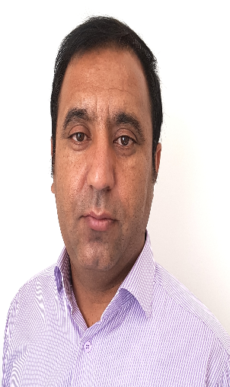 **Curriculum Vitae**

Iraj Ahmadi

Assistant Professort

Departmen of Physiology

Faculty of Medicine, Ilam University of Medical Sciences, Ilam, Iran

Department of Physiology

Email: [Ahmadiiraj57@yahoo.com](mailto:Ahmadiiraj57@yahoo.com)

**EDUCATION**:

Ph.D. (2012-2017) in Medical Physiology, Department of Physiology ,School of Medicine ,Jundi Shahpour University of Medical Sciences, Ahvaz, Iran.

M.Sc in Medical Physiology (2010-2012), Department of Physiology ,School of Medicine ,Jundi Shahpour University of Medical Sciences, Ahvaz, Iran.

BSc, Nursing, Ilam University of Medical Sciences, Ilam, Iran

**TEACHING EXPERIENSES:**

General physiology. Department of Physiology ,School of Medicine, Jundi Shahpour ,Ahvaz University of Medical Sciences, Ahvaz Iran.

Physiology laboratory course. Department of Physiology ,School of Medicine, Jundi Shahpour University of Medical Sciences, Ahvaz, Iran.

Endocrine system physiology to medical students, Department of Physiology School of Medicine, Ilam University of Medical Sciences, Ilam, Iran.

Gastrointestinal physiology to medical students , Department of Physiology School of Medicine, Ilam University of Medical Sciences, Ilam, Iran

Blood cell physiology to medical students , Department of Physiology ,School of Medicine, Ilam University of Medical Sciences, Ilam, Iran

**MSc Thesis Title**:

Assessment of the effect of aqueous and methanolic extract of Saad rhizome on the secretion rate Insulin isolated from islets of Langerhans male mice. With supervised: Dr. Ahangarpour

**Ph.D. Thesis Title** :

The effect of hydrogen sulfide on gastric motility in rats

Healthy and diabetic gastroparesis and determining the role of liberating sensory afferent neurons CGRP. With supervised: Dr. Mard and Professor Gharib Naseri

**Research interests** :

Endocrine system and Gastrointestinal Physiology parameters in animal models and nursing research .

**Technical abilities**:

PCR Electrical recording of isometric and isotonic contractions

Western blot Tissue Bath Isolation

Gavage Blood sampling from the animal heart

Laparotomy ischemia gastric reperfusion

gastric cannulation

**Research Articles**:

[Effect of Boswellia serrata supplementation on blood lipid, hepatic enzymes and fructosamine levels in type2 diabetic patients](javascript:%20void(0))

[Delayed gastric emptying in diabetic rats caused by decreased expression of cystathionine gamma lyase and H2S synthesis: in vitro and in vivo studies](javascript:%20void(0))

[Protective activity of crocin against indomethacin-induced gastric lesions in rats](javascript:%20void(0))

[Sodium hydrosulfide upregulates mRNA and protein expression of TGF-α in gastric mucosa in experimental model of stimulated gastric acid secretion in rats](javascript:%20void(0))

[Sodium hydrosulfide: A new potential candidate for treating delayed gastric emptying in diabetes](javascript:%20void(0))

[Investigating the efficiency of D-Dimer test in diagnosis of aortic dissection: A systematic study and meta-analysis](javascript:%20void(0))

[Prevalence of cutaneous leishmaniasis in different regions of Larestan and its relationship with public health condition during 2014-2015](javascript:%20void(0))

[Parental morphine exposure enhances morphine (but not methamphetamine) preference and increases monoamine oxidase-B level in the nucleus accumbens](javascript:%20void(0))

[Haloperidol's effect on the expressions of TGFB, NT-3, and BDNF genes in cultured rat microglia](javascript:%20void(0))

[Evaluation the multi-organs toxicity of methamphetamine (METH) in rats](javascript:%20void(0))

[Fructose Feeding and Hyperuricemia: a Systematic Review and Meta-Analysis](javascript:%20void(0))

[Somayeh mahdikhani, Ali Gholami. The relationship between Spiritual Well-being and Quality of Life in Patients with Diabetes: a systematic review and meta-analysis](javascript:%20void(0))

[Somayeh mahdikhani, Ali Gholami. The relationship between Spiritual Well-being and Quality of Life in Patients with Diabetes: a systematic review and meta-analysis](javascript:%20void(0))